 | Sydney International School of Technology & Commerce

INDIVIDUAL ASSESSMENT SUBMISSION COVER PAGE
Complete all sections before submitting.
SECTION 1 — STUDENT DETAILS
Full Name | Ridhi
Student ID | 20260668

SECTION 2 — UNIT & ASSESSMENT DETAILS
Unit Code | ICT502
Assessment Title | Assessment 2 – Individual Coding Project

SECTION 4 — ACADEMIC INTEGRITY DECLARATION

By checking the boxes and signing below, I confirm the following:
☒ | This submission is my own original work and has not been submitted for academic credit at this or any other institution.
☒ | I understand and have complied with the SISTC's Academic Integrity Policy.
☒ | Where the work of others has been used, it has been appropriately acknowledged, paraphrased, and cited in accordance with APA 7th referencing style.
☒ | I have not engaged in contract cheating, collusion, fabrication of data, or any other form of academic misconduct as defined by the SISTC's Academic Integrity Policy.
☒ | I acknowledge that breaches of academic integrity may result in serious academic penalties including a fail grade, suspension, or exclusion from the program.

SECTION 5 — ARTIFICIAL INTELLIGENCE (AI) USAGE DECLARATION
SISTC recognises that AI tools may be used in academic work where explicitly permitted. In line with SISTC's Academic Integrity and Misconduct Policy, all students are required to declare whether AI tools were used in preparing this submission.

Transparency and honest disclosure are fundamental to academic integrity. Failure to declare AI usage where it occurred may implies potential academic misconduct.

Select ONE option below:
☒ YES – AI tools were used | ☐ NO – AI tools were NOT used

Complete the table below ONLY if you selected YES above ▼
AI Tool(s) Used | ChatGPT (OpenAI)
Part(s) of Work Assisted | Planning and drafting support for the report; explanation and generation support for HTML, CSS and JavaScript website code.
Nature of AI Assistance | Assistance with organising the report to match the supplied sample outline, explaining code structure and calculator logic, drafting example content, and editing for clarity.
 | Prompts included: “Do this ICT502 assignment based on the assessment brief”; “Create a WanderLux Travel Agency website using HTML, CSS and JavaScript”; and “Prepare the report according to the supplied cover page and sample report outline.”
 | e.g. Brainstorming initial system design ideas
Prompts / Queries Used | Prompts summarised above. The full conversation can be provided as an appendix if required by the unit.

By signing below, I confirm that the above AI Usage Declaration is truthful, complete, and accurate:

Digital Signature  Ridhi  (Sign above) | Date  9/11/2026  (Sign above)

Version 1.0 | Sydney International School of Technology & Commerce | For internal use only

WanderLux Travel Agency
ICT502 – Internet and Web Development | Assessment 2 – Individual Coding Project
Student: ______Ridhi__________ | Student ID: _________20260668_______ | Campus: MEL

Table of Contents
1. Executive Summary
2. Project Overview
3. Code Discussion
3.1 HTML
3.2 CSS
3.3 JavaScript
4. Website Features and Hosting
4.1 Navigation
4.2 Calculator
4.3 Contact Form
5. Recommendations for Future Enhancements
6. Reflection
7. References

1. Executive Summary
This report describes the design and development of WanderLux Travel Agency, a responsive multi-page website created for the ICT502 Assessment 2 scenario. The proposed agency provides personalised holiday planning, guided tours and customised domestic and international travel packages. The website is intended to help visitors understand the agency’s services, explore destinations, estimate a possible trip cost and contact the agency to request assistance.
The project contains six connected pages: Home, Destinations and Services, Trip Cost Calculator, Appointment Request, About Us and Contact. HTML5 provides the page structure, CSS3 controls the visual presentation and responsive layout, and JavaScript supports the rotating destination message, scroll reveal effects, calculator and basic form validation. The calculator uses preset illustrative rates and applies a multiplier for Budget, Standard or Luxury travel styles.
The design uses a consistent navigation bar, travel imagery, destination cards and clear form labels. Accessibility considerations include semantic page regions, alternative text, labelled form controls, a live result region and reduced-motion support. The project is a front-end demonstration rather than a production booking platform. Its contact and appointment forms prepare an email through a mailto link; they do not automatically deliver messages. The rates and contact details are examples and must be verified before real business use. A live hosting URL and genuine form delivery still need to be completed and tested before final submission.

2. Project Overview
The assessment scenario describes WanderLux Travel Agency as a new provider seeking an online presence and new customers. The website responds by presenting the business clearly and helping visitors move from browsing to making an enquiry. It follows the six core pages in the brief rather than creating a generic landing page.
The intended audience includes individuals, couples, families and groups planning a holiday. Some visitors may compare destinations, while others may already know where they want to go and need an initial budget estimate. The site uses plain descriptions, visible navigation and a calculator with four simple inputs. The appointment page collects name, email, phone, preferred date and message. The general contact page provides a separate enquiry form.
The Home page introduces the agency and features a rotating destination caption. Destinations and Services outlines holiday packages, guided tours, flights and hotels, honeymoon specials and other travel options. The calculator estimates trip costs. About Us explains the proposed mission and service values. Contact provides illustrative Melbourne office information, a map and an enquiry form. Business details, staff descriptions and prices are demonstration content because verified agency data was not supplied.
The site uses separate HTML files supported by one stylesheet and one JavaScript file. This keeps content, presentation and behaviour organised while allowing common navigation and visual components to remain consistent. The intended customer journey is to discover the agency, review services, estimate a trip and submit a request.The Home page is designed to create interest, while the calculator gives visitors a practical reason to interact with the site. The forms support the next step by collecting details for a conversation. This structure links the website features to the agency’s business goal of receiving relevant travel enquiries.

3. Code Discussion
The project uses standard HTML5, CSS3 and vanilla JavaScript. No front-end framework or database is required for the current static demonstration. The files are organised so that content, presentation and behaviour are separated. Each HTML page links to styles.css and loads script.js with the defer attribute, allowing the browser to parse the page before executing the script.The six pages use descriptive filenames, which also makes the project easier to navigate during development. The shared script checks whether a relevant element exists before attaching an event listener, so pages without the calculator do not need separate JavaScript files.

3.1 HTML
HTML provides the semantic structure of the six pages. Each document declares English, character encoding and a responsive viewport. Descriptive titles and meta descriptions support basic search presentation. Header, navigation, main, section and footer elements divide content, while a clear heading hierarchy helps visitors and assistive technologies understand each page.
Forms use labels associated with controls. Input types such as email, telephone, date and number support suitable browser behaviour and basic validation. Required fields identify information that must be entered. Images include alternative text, and aria-current identifies the active navigation page. These practices make the site more consistent and accessible.

3.2 CSS
The shared styles.css file controls the visual identity and layout. CSS custom properties define ink, teal, sand and gold colours. The design combines a sans-serif body font, display headings, travel photography, cards and generous spacing. The sticky navigation, buttons and cards use consistent styling so visitors can recognise interactive elements.
CSS Grid supports card layouts on wider screens, while media queries stack content on smaller screens. Flexible widths and responsive heading sizes avoid a fixed desktop layout. Hover and focus states provide feedback, and a reduced-motion rule limits animation for users who prefer less movement. Remote fonts and photographs need an internet connection; local copies and image optimisation would improve production reliability.

3.3 JavaScript
JavaScript provides interactive behaviour. After DOMContentLoaded, an IntersectionObserver watches elements with the reveal class and adds a visible class when they enter the viewport. This creates scroll effects without repeatedly calculating scroll position. The Home page also updates its featured-destination caption.
The calculator stores destination allowances and travel-style multipliers in JavaScript objects. On submission, it prevents a page reload, reads values through FormData and checks the destination. It validates 1–20 travellers and 1–60 days, then calculates and formats the result as Australian dollars. The rates can be updated easily, but they are not live supplier prices.
The form script performs basic client-side checks and prepares an email draft through a mailto link. It does not automatically deliver a message. A real deployment needs a verified form backend and server-side validation.

4. Website Features and Hosting
The project implements six pages, shared navigation, responsive styling, scroll animation, a trip calculator, an appointment form and a contact form. The source includes HTML pages, styles.css, script.js and a README. Open index.html to run it locally. Internet access is needed for remote images, fonts and the embedded map.The page layout also uses meaningful page titles and short descriptions to orient visitors. The README records local opening instructions, the calculator assumptions and the limits of the email demonstration, making the project easier for another person to review.
The assessment permits free hosting such as GitHub Pages or Netlify. The files can be uploaded to a public repository and published from its main branch, or deployed through Netlify. After deployment, add the public URL to this report and test every page on desktop and mobile. A live URL is not included because one has not yet been supplied or verified.
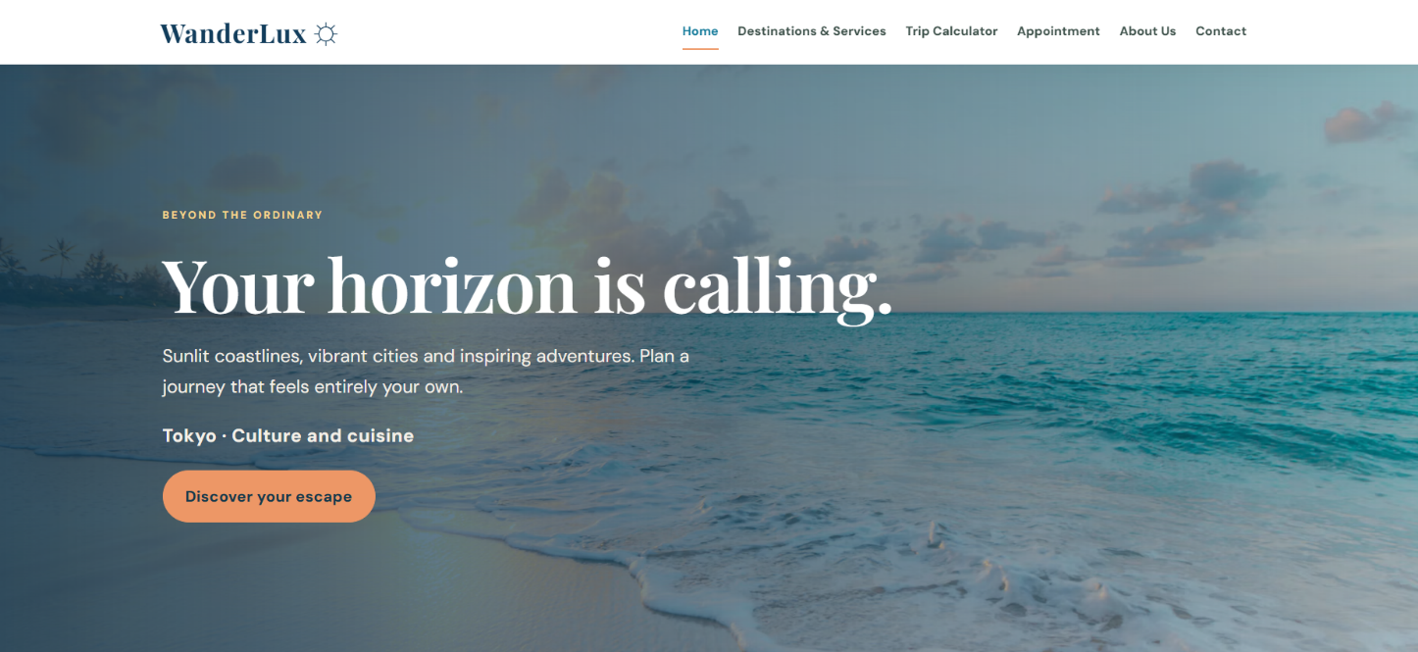

4.1 Navigation
The navigation appears on every page and links to Home, Destinations and Services, Trip Calculator, Appointment, About Us and Contact. aria-current identifies the active page, and links wrap on smaller screens. This predictable menu lets visitors move between sections easily. Screenshot evidence to add: capture the menu on the Home page and one inner page.The menu uses text labels rather than icon-only controls, so the destination of each link is clear. The same menu is repeated across all six HTML documents to reduce the chance that visitors become lost when moving between pages.
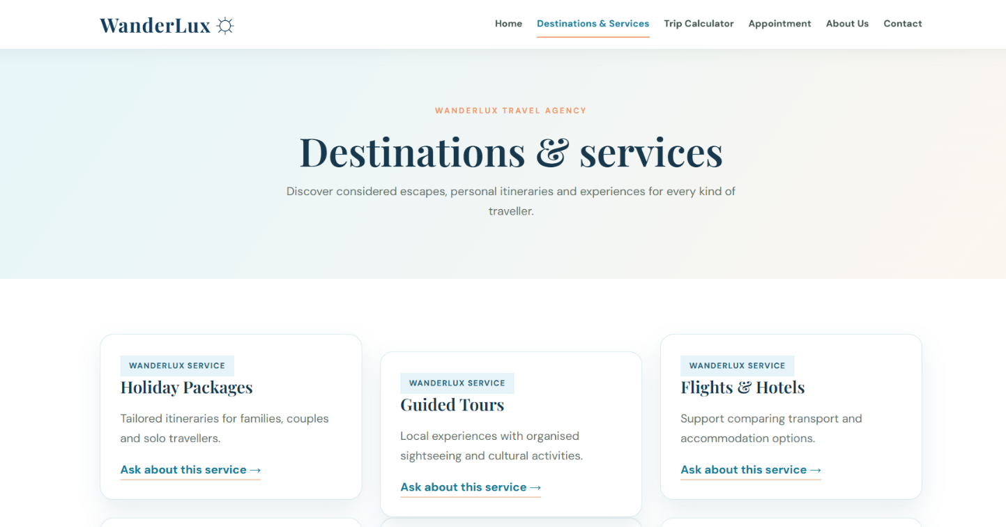
Screenshot evidence to add: capture the navigation at the top of the Home page and one inner page. The screenshots should show the full menu and the browser window width used for testing.

4.2 Calculator
The calculator asks for destination, traveller count, trip duration and travel style. It adds the preset daily and accommodation allowances, multiplies by travellers and days, then applies a style multiplier: Budget 0.80, Standard 1.00 or Luxury 1.65.
For example, Bali uses an illustrative daily allowance of AUD 110 and accommodation allowance of AUD 75. For two travellers over five days on the Standard option, the estimate is (110 + 75) × 2 × 5 × 1.00 = AUD 1,850. The output is an estimate only; it excludes live flight prices, visas, insurance, seasonal changes and supplier availability. It should not be treated as a confirmed quote.For Bali, the daily allowance is AUD 110 and the accommodation allowance is AUD 75. Two travellers for five days on Standard produce (110 + 75) × 2 × 5 × 1.00 = AUD 1,850. The result area explains the selected trip and displays a formatted AUD amount.
The amount is an estimate only; it excludes live flight prices, visas, insurance, seasonal changes and supplier availability. It is not a confirmed quote. Screenshot evidence to add: capture the completed form and estimate, then test a boundary value and an invalid value.
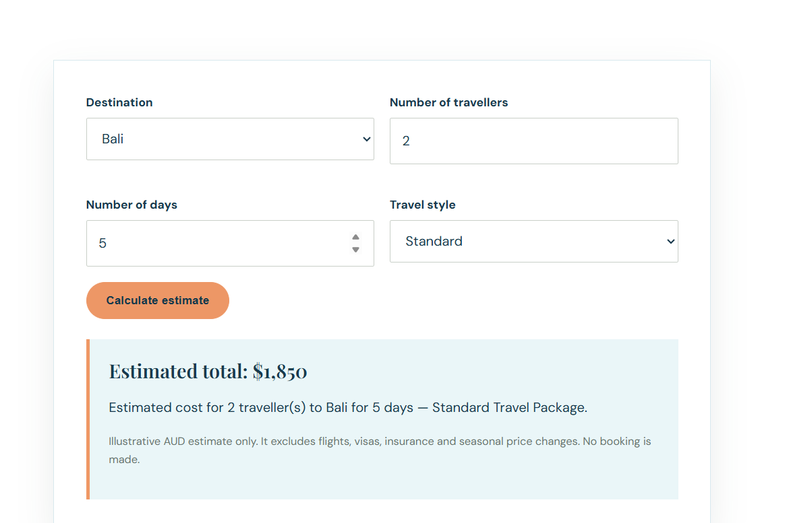

4.3 Contact Form
The Contact page collects name, email, subject and message. The Appointment page separately asks for name, email, phone, preferred date and message. Required attributes and input types provide basic browser validation, while labels identify each field.
The forms currently use mailto to open a prepared email. They do not send from the website server; the visitor must use an email application and press Send. Replace the example recipient with a verified address. To meet the direct-email requirement, connect and test a form backend. Screenshot evidence to add: show the form and, after integration, a successful confirmation.
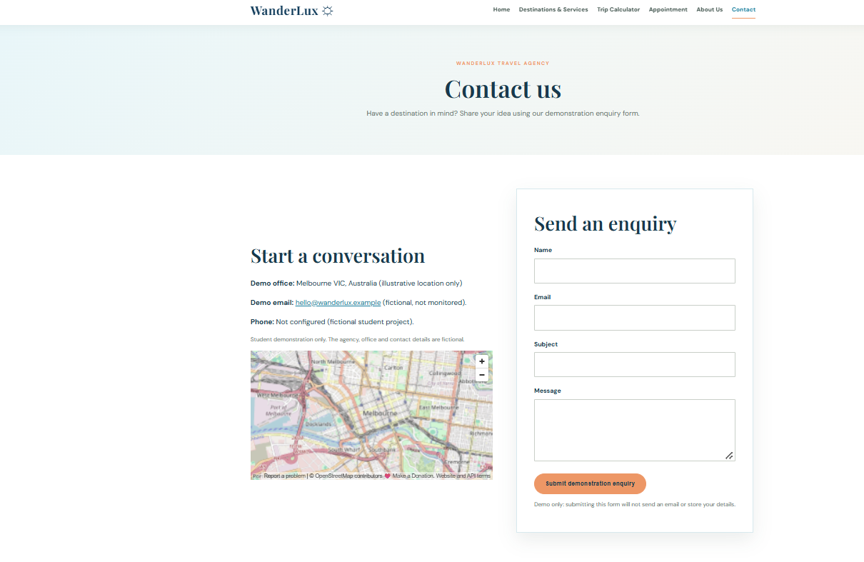

5. Recommendations for Future Enhancements
The first priority is connecting the forms to a secure email service or serverless function. Use a verified recipient, success and error messages, spam protection and server-side validation. A privacy notice should explain how enquiry information is handled.
The calculator could use updated supplier rates, separate flight and accommodation costs and show a breakdown. Future features could include itinerary saving, destination filters, FAQs and testimonials. These additions would help visitors compare options and make informed decisions.
Before real use, verify all contact details, staff profiles, map information, packages and prices. Check image permissions, optimise photographs and test keyboard navigation, contrast, mobile layouts, browser compatibility and form errors.

6. Reflection
This project helped me understand how HTML, CSS and JavaScript work together in a business scenario. A website is more than separate pages: structure, design and interaction must support a clear purpose. Planning the six pages first helped divide the work into manageable tasks.
One challenge was keeping pages consistent while giving each a different purpose. I used a shared stylesheet, common navigation and reusable classes. Another challenge was creating an understandable calculator. Separating destination rates from travel-style multipliers made the formula easier to maintain. Testing different values also showed why user input must be validated.
The contact form requirement was another challenge. A static HTML page cannot securely send email by itself. The current mailto approach creates a draft but depends on the visitor’s email software, so it is not automatic delivery. The next step is to connect a form backend and test a real submission.
The project improved my awareness of accessibility and responsive design. Labels, semantic elements, alternative text and reduced-motion support help different users operate a website. Flexible layouts also need testing at several screen sizes. I still need to deploy the site, capture genuine screenshots and test the hosted version. Overall, the prototype covers the main structure and interaction goals, while hosting and direct email remain to be completed.I also learned to distinguish between a feature that looks complete and one that has been tested in a real environment. For example, a form can display correctly but still fail to deliver a message. This is why I have recorded the email limitation and the need for a hosted test rather than assuming that the intended outcome has been achieved.

7. References
Mozilla. (n.d.). HTML: HyperText Markup Language. MDN Web Docs. https://developer.mozilla.org/en-US/docs/Web/HTML
Mozilla. (n.d.). CSS: Cascading Style Sheets. MDN Web Docs. https://developer.mozilla.org/en-US/docs/Web/CSS
Mozilla. (n.d.). JavaScript. MDN Web Docs. https://developer.mozilla.org/en-US/docs/Web/JavaScript
Mozilla. (n.d.). Intersection Observer API. MDN Web Docs. https://developer.mozilla.org/en-US/docs/Web/API/Intersection_Observer_API
World Wide Web Consortium. (2023). Web Content Accessibility Guidelines (WCAG) 2.2. https://www.w3.org/TR/WCAG22/

Appendix A – AI assistance record
AI assistance was used for planning, drafting and code-support activities. The student should review, understand, test and revise all submitted work and ensure that the final submission accurately represents their own learning and work. The prompts listed on the cover page are brief summaries of the assistance requested.

Coastal Edition: Design and Implementation Notes
This second version uses an ocean-inspired palette, rounded destination cards, a bright coral call-to-action and a beach-themed hero. These visual decisions distinguish the site from the earlier dark-teal luxury concept. The six required pages, shared CSS and JavaScript interactions are retained. The source code is included in a separate ZIP file.

Evidence to add after testing
Homepage and navigation screenshot: ______________________________________________
Trip calculator screenshot with an estimated result: ______________________________________________
Contact form screenshot showing demo-only confirmation: ______________________________________________
GitHub Pages live URL and mobile view screenshot: ______________________________________________

Personal reflection and declaration reminder
The student must rewrite the reflection to describe their own testing, corrections and learning. The original SISTC cover page contains an AI declaration that must be answered truthfully. This version was created with ChatGPT assistance for website code and report adaptation. Student name, ID, signature, date and actual GitHub URL must be entered by the student.

